UNIVERSITI TUNKU ABDUL RAHMAN
Faculty of Information and Communication Technology



UCCD3223 Mobile Applications Development
(June 2024 Trimester)

Individual Practical Assignment

Name | TAN ZONG TING
Student ID | 23ACB02731
Course | CN
Practical Group | P2
Lecturer | Mr. Tan Chiang Kang @ Thang Chiang Kang

Marking scheme | Marks | Remarks
Correctness of output | × 2.5
Design of UI | × 2.5
User Friendliness | × 3
Neat Program Documentation
Report Format
TOTAL

Homepage of Loan Calculate
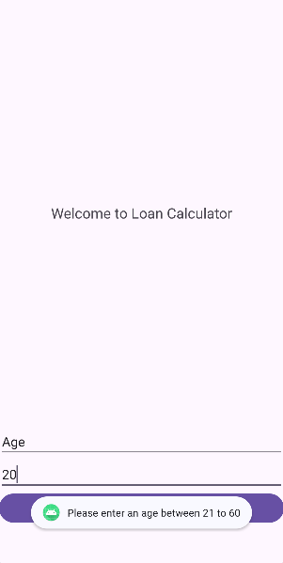
Figure 1
According to the bank in Malaysia, the minimum age for having personal loan or any loan is 21 years old and above and maximum of the age will be 60 years old. Therefore, when the user enter age below 21 and above 60. It will pop out an alert message (Figure 1). After popped out the message, user can enter the correct age again. Then it will pop out an alert message “Submitted successfully” shown as Figure x.

Selection Page of Loan Calculate
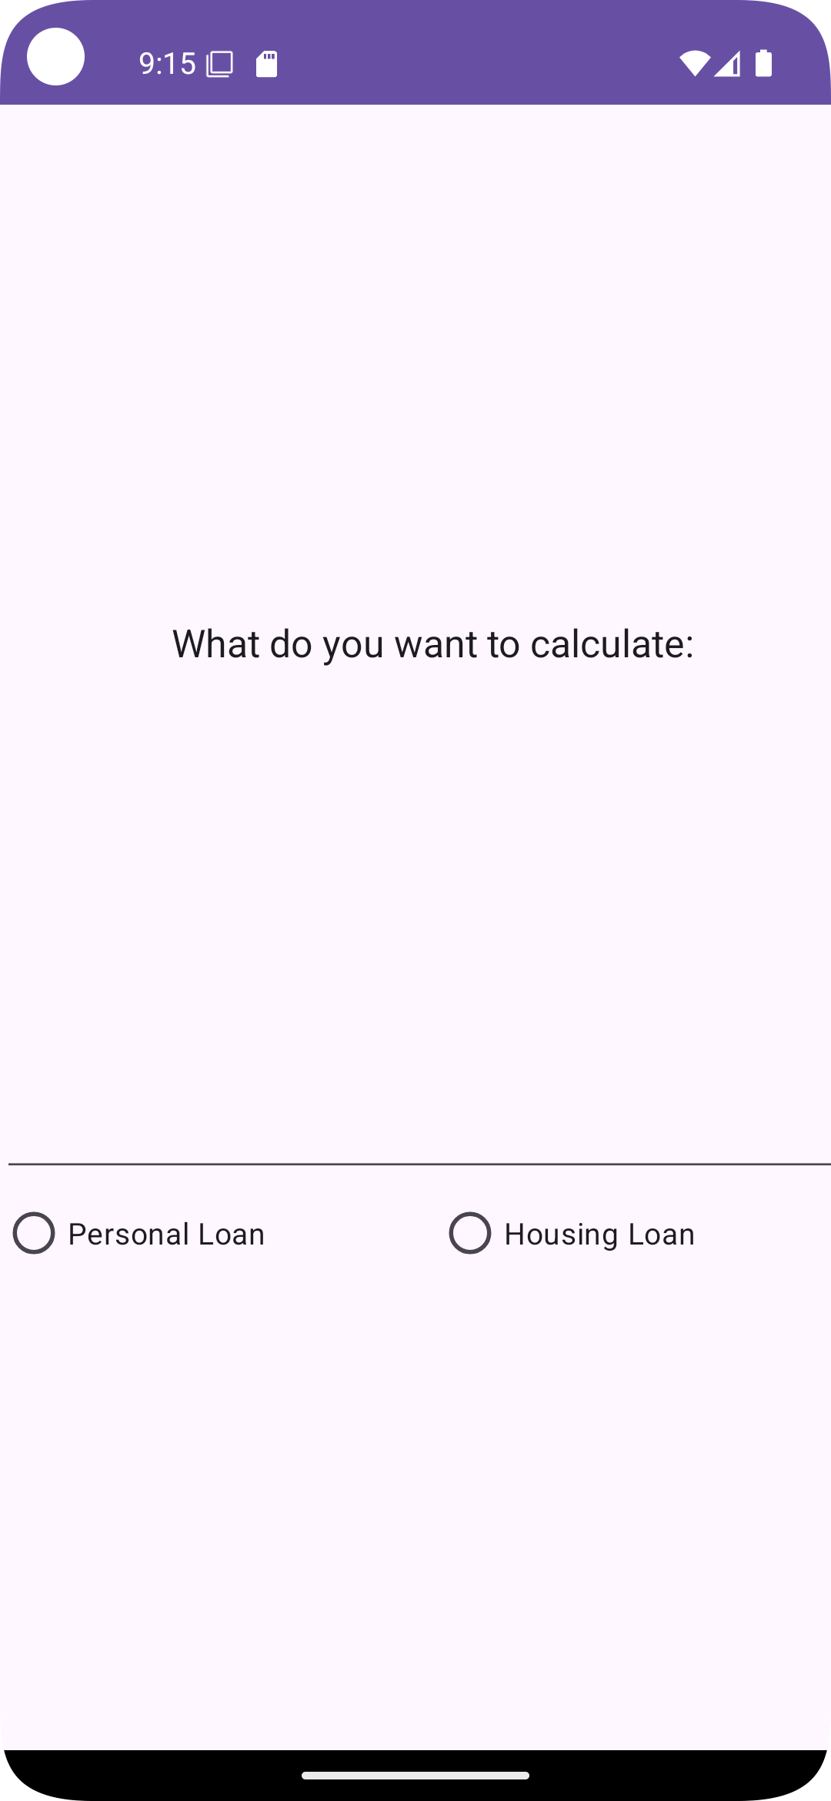
Figure 2
After user enter their age on the Figure 1, it will proceed to the next page will is the selection as shown as Figure 2. In this section, user may choose one of the following which is Personal Loan and Housing Loan.

Personal Loan Calculation page

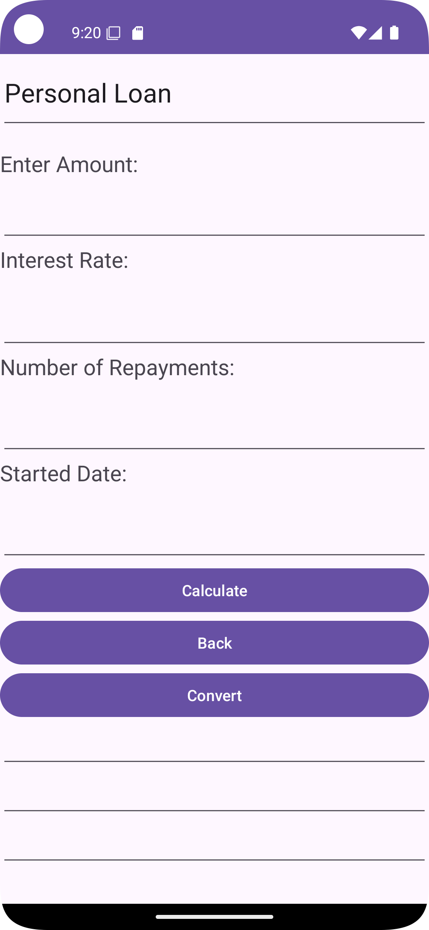
Figure 3
When the user clicked on the Personal Loan button in Figure 2, it will proceed to personal loan calculation page. Then the user can enter the loan amount, interest rate, number of repayments and the started date which provides in Figure 3.

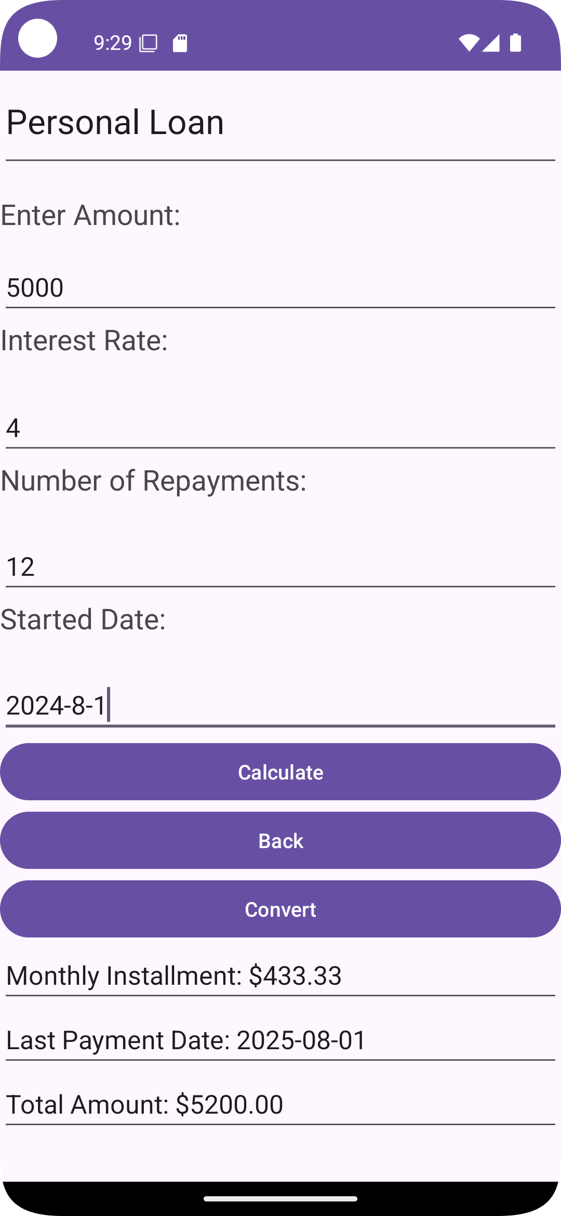
Figure 4
For example, if the user enters total amount RM5000, interest rate 4%, number of repayments 12 and the started date 1st August 2024. After clicking the “Calculate” button, the result of monthly instalment, last payment date and total amount will be shown at the bottom of the third button. (Figure 4)

Table of Amortization Schedule table (personal loan)
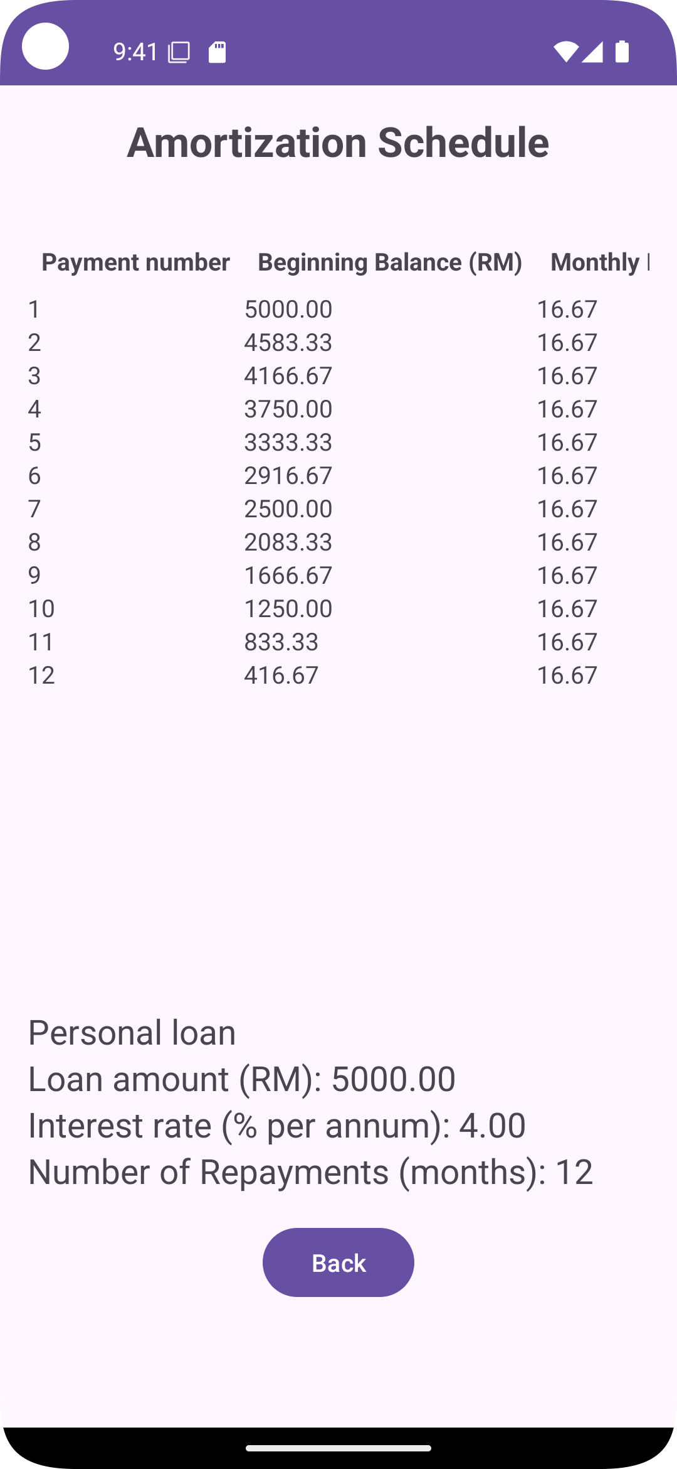
Figure 5
When the user clicked on “Convert” button, it will lead them to the amortization schedule table shown above. This amortization schedule will show the payment number, beginning balance (RM), Monthly payment (RM), Interest paid (RM), and Principal paid (RM). This table have a function which is scrolling up and down, left and right. It has a “Back” button which can lead the user back to the personal loan in Figure 4.

Housing Loan Calculation page
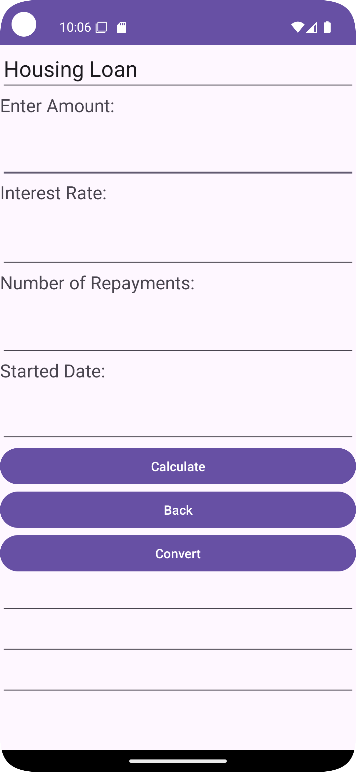
Figure 6

When the user clicked on the Housing Loan button in Figure 2, it will proceed to housing loan calculation page. Then the user can enter the loan amount, interest rate, number of repayments and the started date which provides in Figure 6.

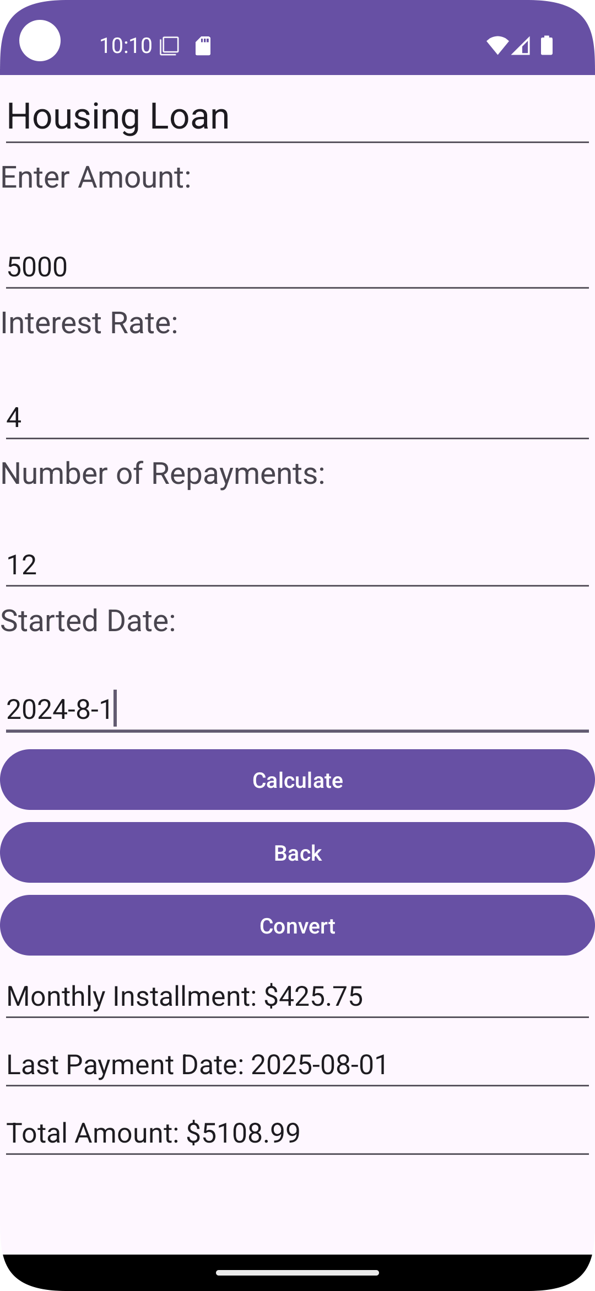
Figure 7

For example, if the user enters total amount RM5000, interest rate 4%, number of repayments 12 and the started date 1st August 2024. After clicking the “Calculate” button, the result of monthly instalment, last payment date and total amount will be shown at the bottom of the third button. (Figure 7)

Table of Amortization Schedule table (housing loan)
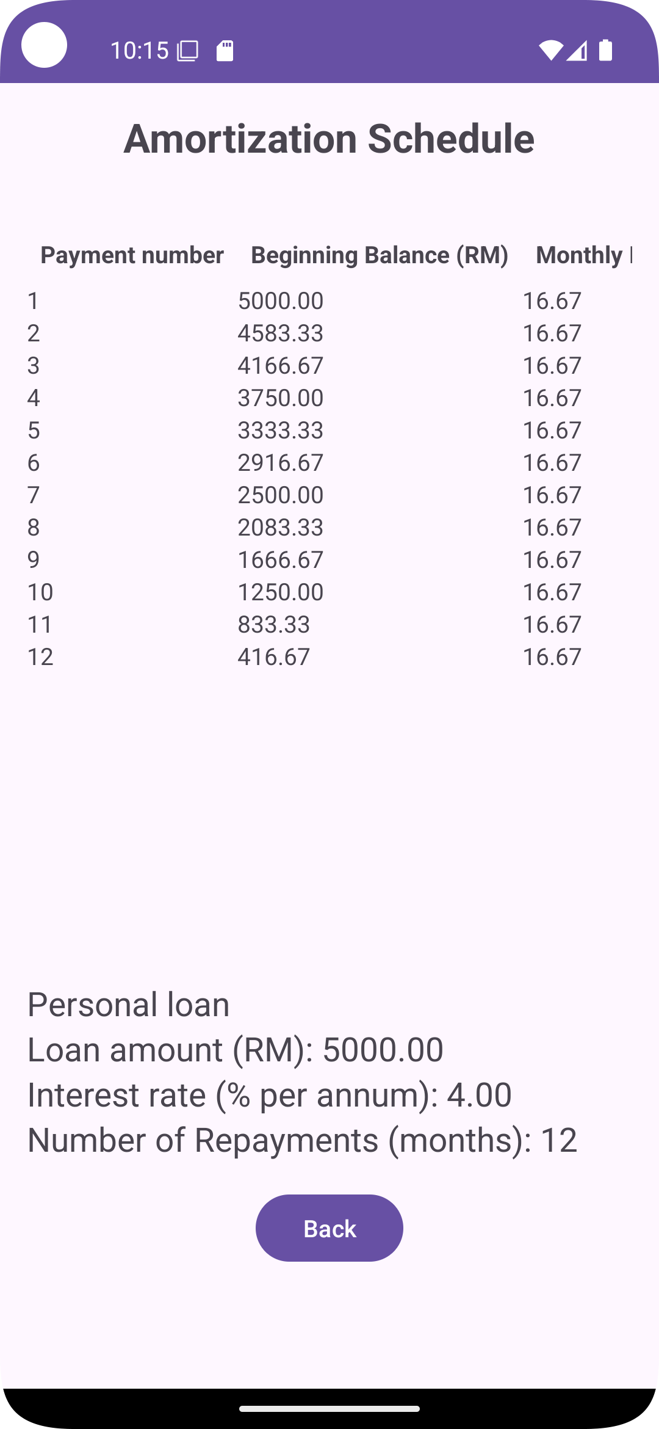
Figure 8

When the user clicked on “Convert” button, it will lead them to the amortization schedule table shown above. This amortization schedule will show the payment number, beginning balance (RM), Monthly payment (RM), Interest paid (RM), and Principal paid (RM). This table have a function which is scrolling up and down, left and right. It has a “Back” button which can lead the user back to the personal loan in Figure 8.

Appendix

Welcome to Loan Calculate.kt
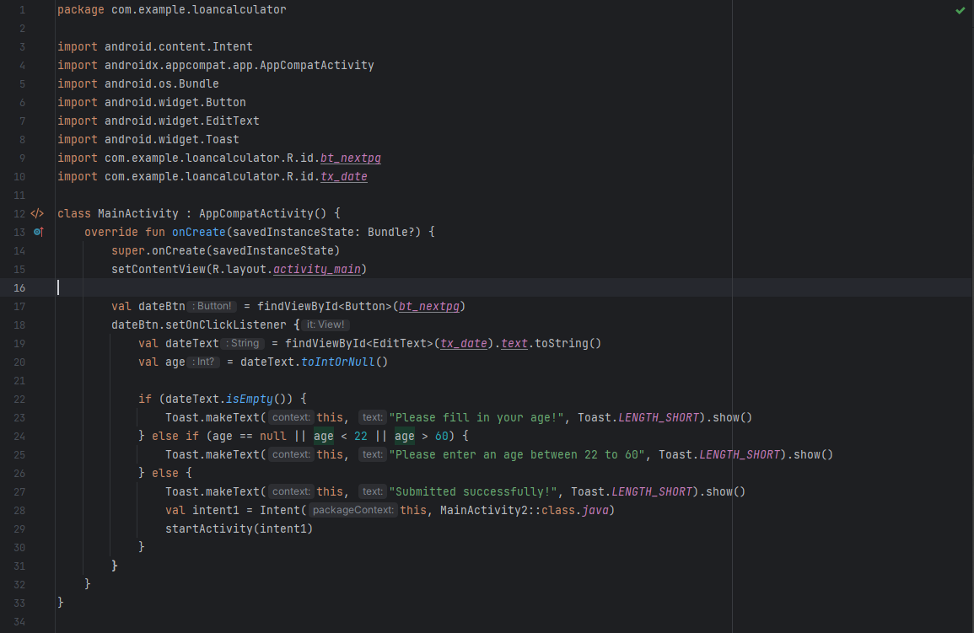

Selection.kt
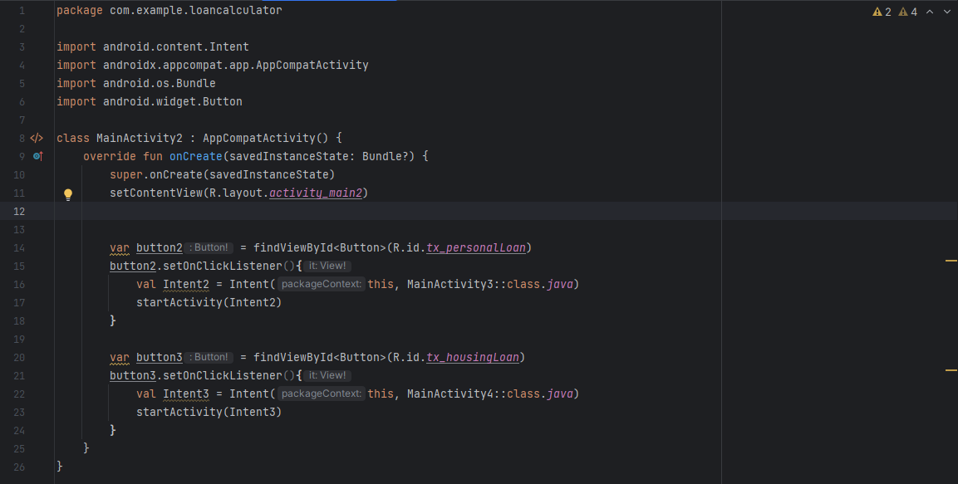

Personal Loan.kt
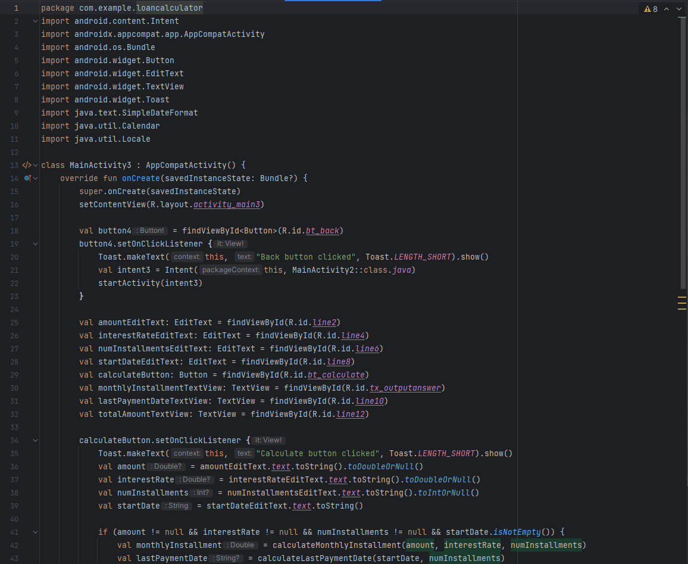

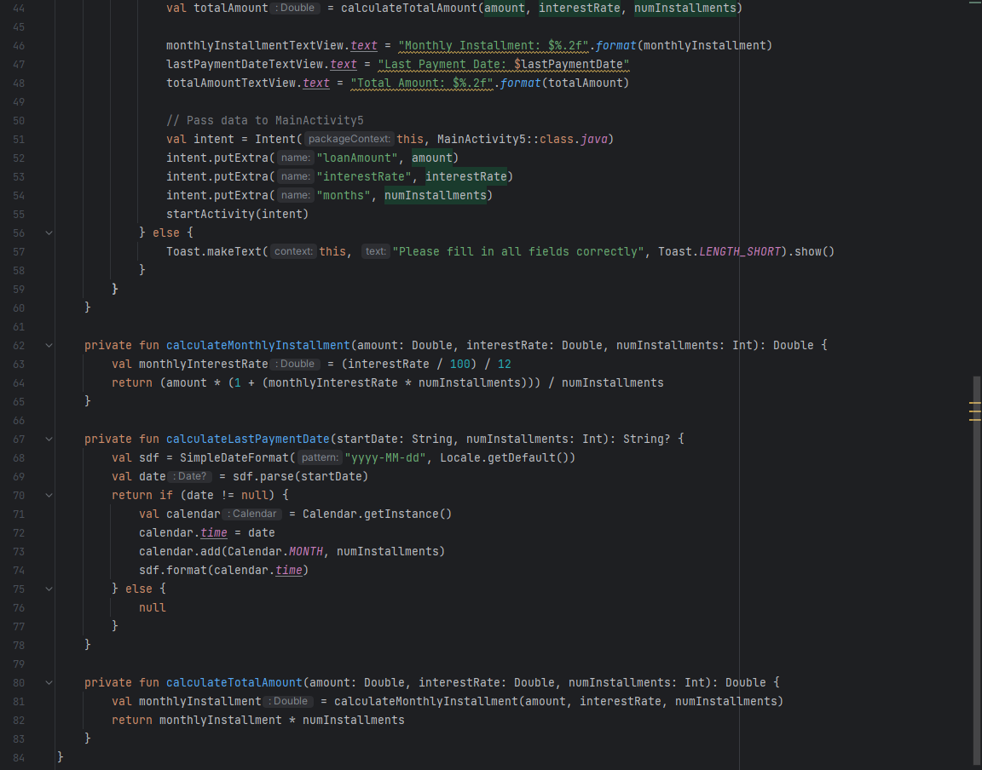

Housing Loan.kt
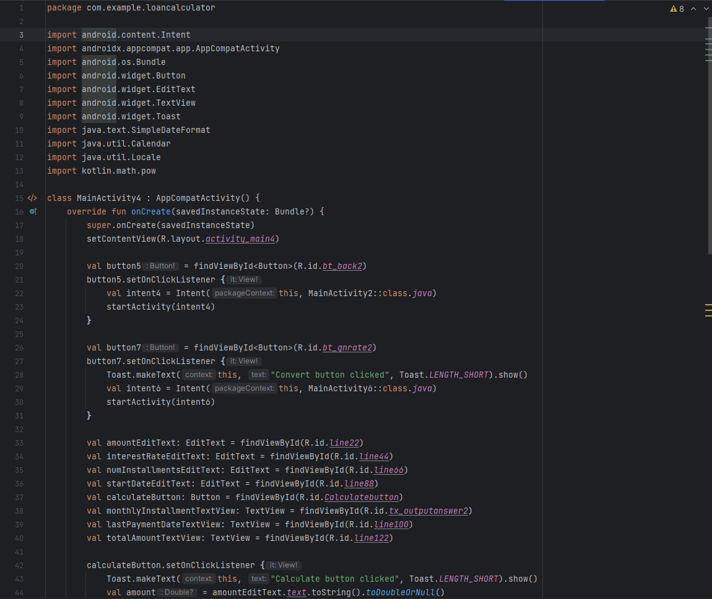

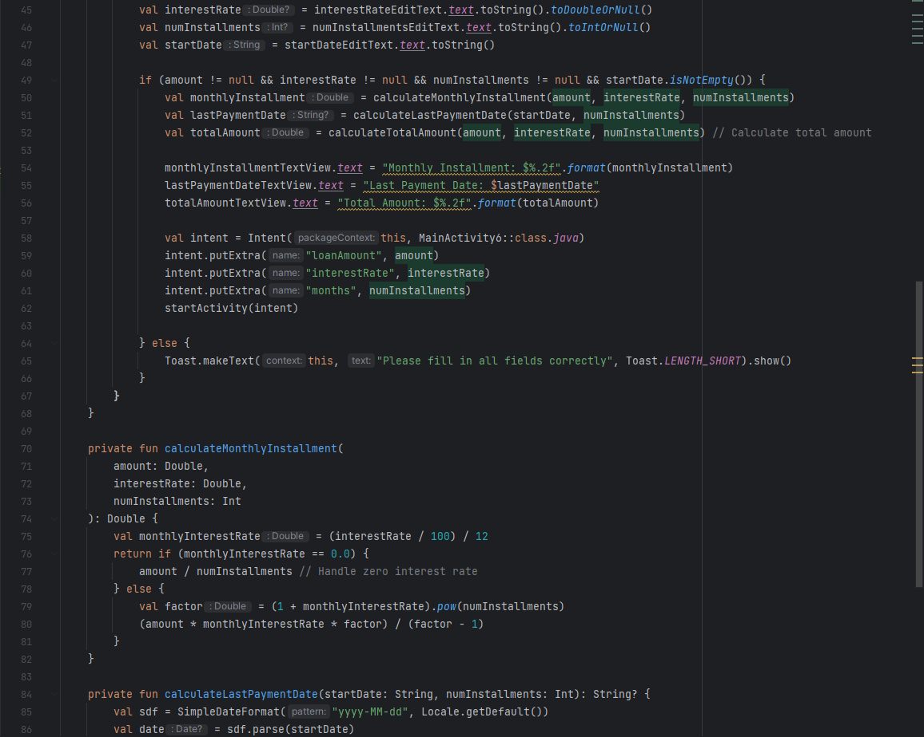

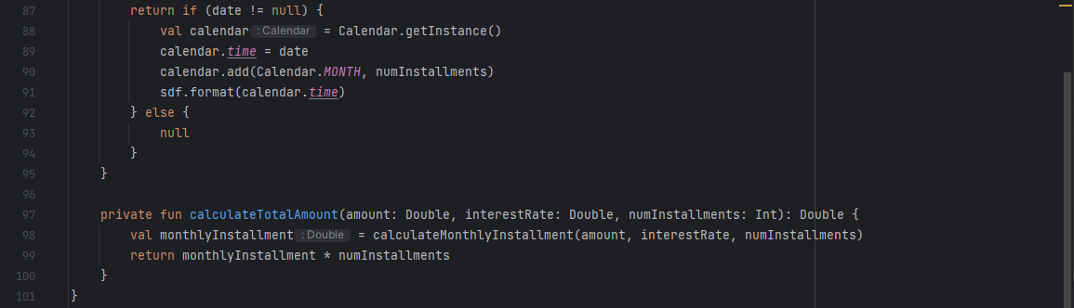

Amortization Schedule (personal).kt
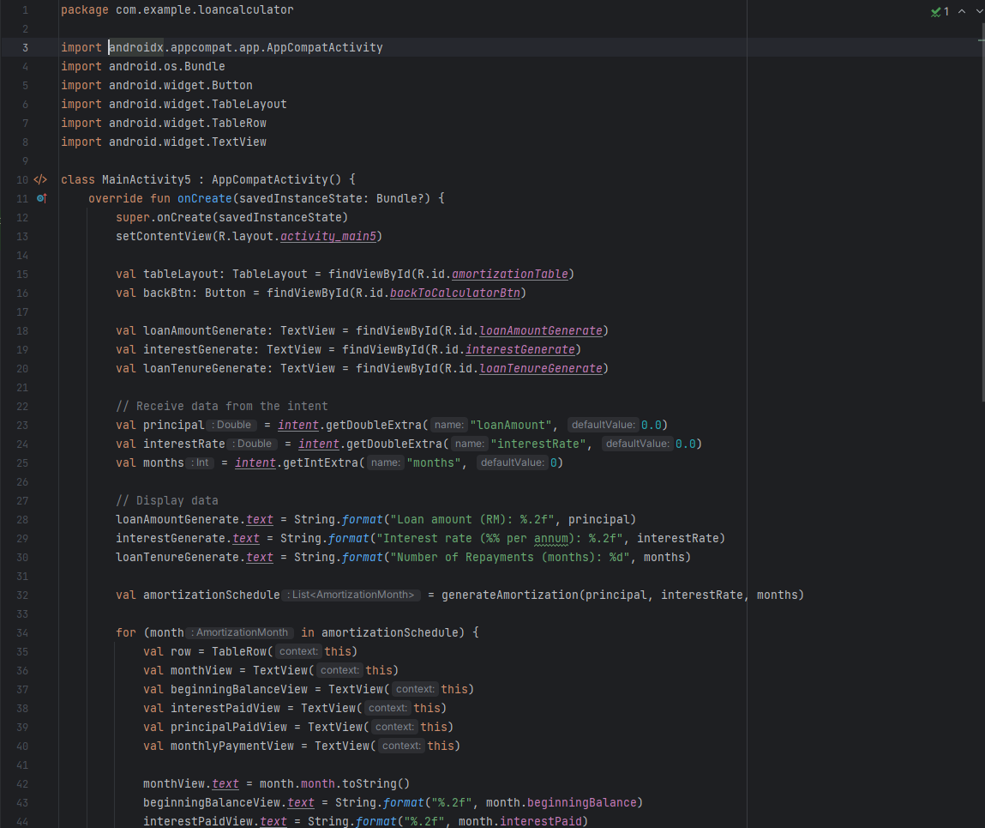
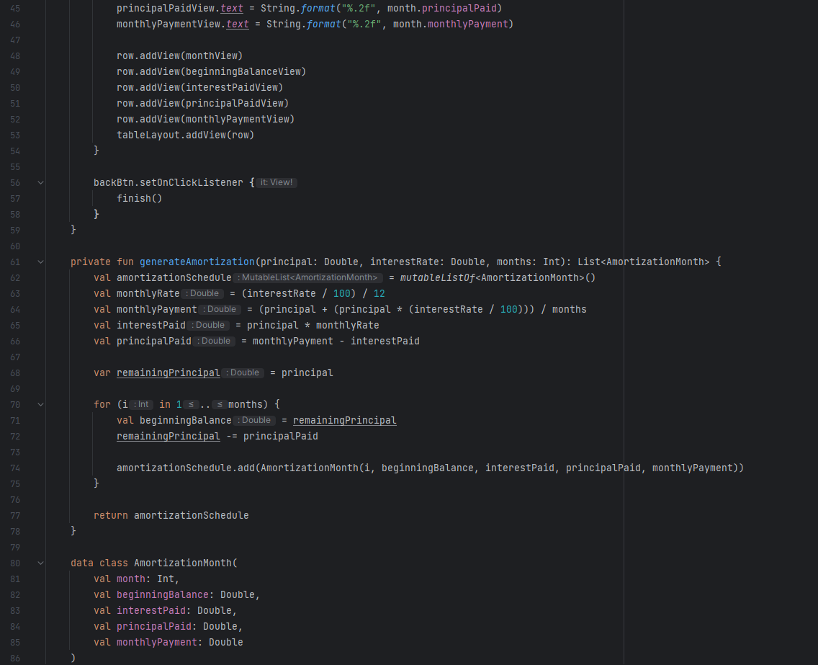

Amortization Schedule (housing).kt
